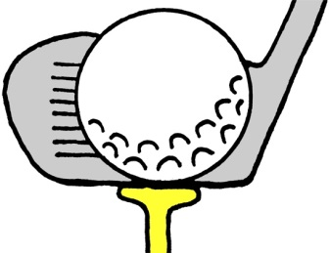 Four Man Scramble Golf Tournament
Friday, May 8th, 2020
The J. W. Hoysradt Hose Company #8 of The City of Hudson Fire Department is hosting our first annual J. W. Hoysradt Hose Memorial Golf Tournament at the Copake Country Club. The tournament will be on Friday, May 8th with a check in time of 8am and Shotgun Start at 9 am. Lunch will be served on the turn at the course and include hamburgers and hotdogs. A chicken dinner will be served afterwards at Copake Country Club and Greens Restaurant. There will also be a 50/50 raffle with proceeds being donated to the National Fallen Firefighters Foundation, various prizes raffled off after the tournament as well as prizes rewarded for “Closest to the Pin” and “Longest Drive”. Entry is $100 per person and the deadline for entry is Friday, April 24th, 2020. Return this form and fees to J. W. Hoysradt Hose Co. 8, PO Box 224, Hudson, NY 12534. Contact Conor O’Neill with any questions, (518)567-8459.
Names:

Team Contact Name and Phone Number

